ScaleName | Construct | Proportion complete obs.
SDAB | ADHD - Attention Deficit | 0.724
SDAG | ADHD - Attention Deficit | 0.587
SDAI | ADHD - Attention Deficit | 0.933
SDAB | ADHD - Hyperactivity | 0.726
SDAG | ADHD - Hyperactivity | 0.587
SDAI | ADHD - Hyperactivity | 0.933
AU | Auditory Attention - Inhibition | 0.995
AU | Auditory Attention - Omissions | 0.994
AU | Auditory Attention - Selection | 0.996
CP | Continuous Performance Task | 0.989
AD | Executive Function - Divided Attention | 0.05
MLP | Executive Function - Planning | 0.079
KBIT | General Intelligence | 0.999
Counting (BDE-2) | Math-Counting | 0.46
Mental Calculation (BDE-2) | Math-Mental Calculation | 0.46
Triplette (BDE-2) | Math-Number Comparison | 0.407
Insertion (BDE-2) | Math-Number Line | 0.407
Numerical Reasoning (AC-MT-3) | Math-Numerical Reasoning | 0.35
QSTmilan_parent | Sense of Time | 0.176
QSTmilan_teacher | Sense of Time | 0.939
QSTpadua_parent | Sense of Time | 0.587
QSTpadua_teacher | Sense of Time | 0.311
TD | Time Discrimination | 0.924
TE | Time Estimation | 0.992
ITQ | Time Knowledge | 0.63
OTm | Time Orientation | 0.728
OTp | Time Orientation | 0.598
TR | Time Reproduction | 0.955
Corsi | VisualSpatial WM | 0.999

Method
Sample
A total of xx primary school children aged 6 to 11 years participated in the study, recruited from xx different schools to ensure a representative distribution across primary school grades (1st to 5th grade), with approximately xx participants per grade (xx to xx). Recruitment of this sample was conducted entirely in public schools to obtain a sample reflecting the natural variability of the general population (the large majority of children, regardless of socioeconomic status, attend public primary schools in Italy). Consequently, a small number of children with already identified neurodevelopmental conditions were included: specifically, a few participants had a prior diagnosis of ADHD and a few presented learning disabilities. Consistent with a dimensional approach to neurodevelopmental conditions, no participants were excluded on this basis, as they were considered as part of the lower end of a developmental continuum. The overall sample presented xx% female participants and xx% male participants. The target sample size was chosen to xx.
Data were collected using a multi-method, multi-informant design. Children completed a battery of tasks assessing time-processing abilities (including time estimation, time reproduction, and time discrimination), executive functions (e.g., inhibition, working memory, attention), and non-verbal intelligence (KBIT matrices). Additionally, they completed a child self-report version of the Sense of Time Questionnaire (STQ). Teachers and (where available) paernts filled in proxy-report versions of the STQ and standardized rating scales. Assessments were conducted during school hours, with collective tasks administered in classrooms and individual tasks completed in quiet rooms within the school setting. Parents’ and teachers’ questionnaires were administered online via secure links sent with informed consent documentation. The research protocol was approved by the academic Ethics committee of [blind].

Tools and procedures
Data collection was conducted during school hours; it included both collective and individual assessment. Additionally, parents and teachers completed proxy-report questionnaires. The time processing abilities in children were evaluated through 3 ad-hoc computerized tasks and the Sense of Time Questionnaire (STQ) which is composed of 3 versions (children, parent and teacher). Tests were also administered to assess executive functions, including attention, inhibition, and visuo-spatial memory.
Time Estimation Task. The time Estimation task (TE; based on Stojić et al., 2023) involves presenting two different videos via the interactive whiteboard (LIM) in the classroom. The videos, created using Artificial Intelligence (AI), have a duration of 30 seconds each. The first video (called “the thief”) has a fast musical background; the second one (called “the boat”) has a slow musical background. The participant has to estimate the duration, in terms of number of seconds, of the two videos shown. The score was calculated as the absolute average deviation (regardless of whether it is an overestimation or underestimation) from the target duration, calculated as the difference between the duration indicated by the child and the target duration (30 seconds).
Figure 1
Frame Video 1 (The Thief) and Frame Video 2 (The Boat) for Time Estimation task


Time Reproduction Task. The time reproduction task (TR) was developed via the builder environment of PsychoPy 2023.2.3 (Peirce, J. W. et al., 2022) and subsequently reproduced with OpenSesame 4.0.24. TR is based on the research of Moll and colleagues (2016), was used to assess via computer the ability of reproducing temporal durations (Tobia et al., 2018). The participant was presented in front of a 20x24 cm monitor with a bulb (fig.2) which was lighted up for several default time durations (2, 3, 4, 5, 6, 7, 8, 9, 10, 11 and 12 seconds). When the bulb was turned off, the participant was called out to light up the bulb and keep it lit for the target duration by pressing the PC spacebar. The task is composed of 15 trials. The task environment is very simple in order to minimize the effect of any source of distraction for the participant. The score was calculated as the absolute average deviation from the target for each trial (larger scores indicate lower accuracy). These absolute deviations were then transformed into percentiles relative to a Gaussian distribution to normalize scores. Internal consistency across trials was excellent, with Cronbach’s alpha = 0.88. Confirmatory factor analysis supported a single latent trait structure, with fit indices RMSEA = 0.040, CFI = 0.979, and NNFI = 0.973.
Figure 2
Target used for TR task
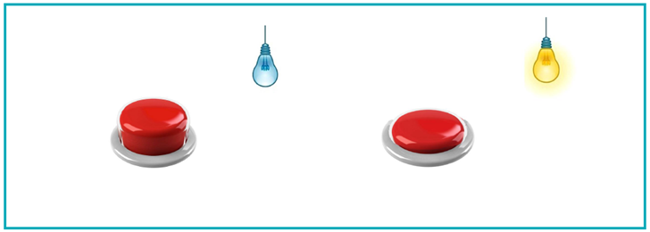

Time Discrimination Task. Il task di Time Discrimination (TD), che è stato creato con il software di PsychoPy (2023.2.3), valuta la capacità di discriminare due durate temporali (Tobia et al., 2018). Al partecipante vengono presentati, 2 suoni (39 trial (3 d’esempio); durate: da 0,3s a 7,5s, con ratio di difficoltà crescente) abbinati all’immagine di due animali che sentono la musica (Figura 3), presentati sullo schermo del monitor di un computer (20 x 24 cm). Il task consiste in un compito di discriminazione delle durate presentate simultaneamente in modalità uditiva e visiva. Nei bambini più piccoli, la presentazione congiunta delle due modalità favorisce sia l’attenzione al compito sia l’accuratezza delle risposte (Tobia et al., 2018). Durante il task, il partecipante deve indicare, utilizzando la tastiera del computer, quale tra i due animali ha percepito il suono più lungo (tasto Q per l’animale a sinistra, tasto P per l’animale a destra). L’esperimento prevede la somministrazione di item gradualmente più difficili (con Ratio decrescente) man mano che il bambino risponde correttamente; quando il bambino risponde in modo errato si ha un reversal, che prevede il ritorno a una Ratio più alta. Il punteggio ottenuto è dato dalla media degli ultimi 6 reversal, chiamata Ratio. Il metodo di calcolo è il seguente: 1) rimozione dei primi due reversal; 2) calcolo della media degli ultimi 6 reversal. Nel caso in cui i reversal rimanenti sono meno di 6, si calcola la media di quelli disponibili.
The time discrimination (TD) task was developed via the coder environment of PsychoPy 2023.2.3 (Peirce, J. W. et al., 2022), and subsequently reproduced with OpenSesame 4.0.24. It was administered to each participant in order to assess the ability of discriminating the length of two temporal duration (Tobia et al., 2018). The task was composed of 39 trials with auditory stimuli of adaptable length between 0.3 and 7.5s; in order to facilitate the task, each sound was coupled with the image of an animal as depicted in fig. 3 (Tobia et al., 2018). The participant is required to press respectively the Q- or the P- key on the PC keyboard in order to identify the longer sound linked to the left or to the right picture. Each participant was presented with stimuli of variable difficulty, i.e. with increasing or decreasing length ratio according to the precision of the performance.
Figura 3. Example target images for TD task
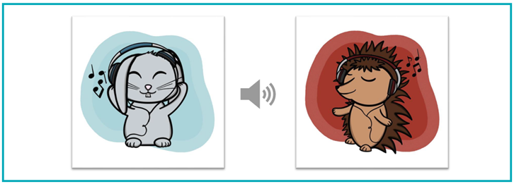

Sense of Time Questionnaire. The child version of the STQ (based on Rosselló & Servera, 2015; Porcelli et al., 2018) consists of 16 items with both open- and closed-ended responses. The items provide two separate scores. The first one is Temporal Orientation, which reflects a score partially related to general semantic knowledge about time. The second one is Time Management which evaluates the ability to use time to organize one’s daily life. The parent and teacher versions of the STQ (Tobia et al., 2018; based on Houghton et al., 2011) consist of 10 items rated on a 4-point Likert scale ranging from 1 (never or rarely) to 4 (very often). The final score (one for each informant) is obtained by summing the responses of the items.

